**Snake classification as venomous and non-venomous through deep learning models**

Snakes are warm-blooded reptiles belonging to the phylum Serpentes. Their physical characteristics, including head appearance, body structure, skin type, and eyes, are employed to distinguish between venomous and non-venomous snake species. However, this identification is not universally reliable and requires expertise to ascertain accurately. Reliable identification of snake species as venomous or non-venomous is crucial for understanding their characteristics and providing appropriate treatment for individuals bitten by snakes. Automated snake identification systems can serve as early warning systems, prompting individuals to take necessary precautions and exercise caution. Artificial intelligence techniques, particularly machine learning and deep learning, have proven instrumental in achieving accurate snake identification. In this project, a deep learning model known as Convolutional Neural Networks (CNNs) has been employed for the classification of snakes into venomous and non-venomous categories.

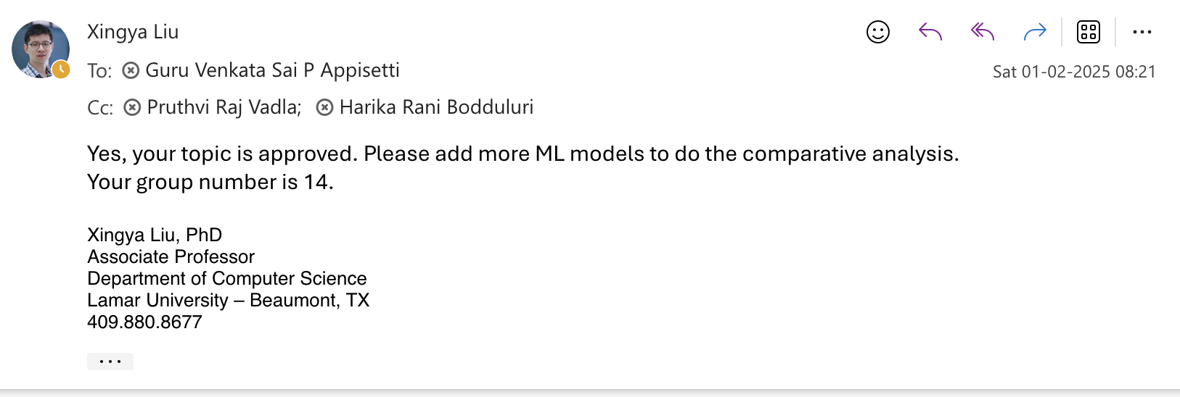

Team Members

Pruthvi Raj Vadla

Harika Bodduluri

G V S P Kumar Appisetti